# Supplementary File D. Multicenter external validation of Meta risk scoring models

## D.1 Baseline characteristics of the external validation population

The Kailuan population had a mean survival time of 55.1 months, a mean age of 57.4 years, a mean BMI of 25.0 kg/m2, 81.23% males, 58.57% smokers, 80.54% physical inactivity, and 48.35% hypertensive patients. The average FBG of blood test index was 5.2mmol/L, the average TYG was 8.6, the percentage of lower HDL-C was 10.86%, and the percentage of high uric acid was 9.11%.

The average survival time of the Hongguang population was 37.3 months, the average age was 69.8 years, the average BMI was 24.1 kg/m2, the proportion of males was 45.78%, the proportion of smokers was 29.22%, the proportion of those who lacked exercise was 17.72%, the proportion of those who were hypertensive was 28.27%, and the presence of a family history of diabetes was 25.99%. The average FBG was 5.3 mmol/L, the average TYG was 8.6, and the average HDL-C was 13.44%.

The average survival time of the Baoan population was 32.2 months, the average age was 67.0 years, the average BMI was 24.4 kg/m2, the proportion of males was 50.59%, the proportion of smokers was 24.07%, the proportion of those who lacked exercise was 30.25%, and the proportion of hypertensive patients was 74.85%. The average FBG was 5.3 mmol/L, the average TYG was 5.3, the average HDL-C was 30.96%, and the average uric acid was 29.76%.

Data on family history of diabetes were missing in the data from Kailuan and Bao'an, data on uric acid were missing in the data from Hongguang. The missing variables were assigned a value of 0 in the model. The baseline characteristics of the three external validation populations are shown in S4 Table.

S4 Table Baseline characteristics of the external validation population

|  |  |  |  |  |  |  |  |  |  |  |  |  |  |  |
| --- | --- | --- | --- | --- | --- | --- | --- | --- | --- | --- | --- | --- | --- | --- |
| Risk factor | | Kailuan | | | | Hongguang | | | | Baoan | | | | *P* for all |
| No  (64209) | Yes  (4443) | all | *P* | No  (7168) | Yes  (434) | all | *P* | No  (111775) | Yes  (10163) | all | *P* |
| Survival time [Med (IQR), month] | | 60.0 (60.0; 60.0) | 37.0 (29.0; 51.0) | 60.0 (57.0; 60.0) | <0.001 | 37.0 (19.0; 60.0) | 27.0 (14.0; 42.0) | 36.0 (19.0; 60.0) | <0.001 | 32.8 (26.2; 40.2) | 12.7 (3.2; 24.6) | 32.2 (23.9; 39.7) | <0.001 | <0.001 |
| Age [Med (IQR), years] | | 55.0 (51.6; 60.7) | 55.6 (51.6; 61.8) | 55.0 (51.6; 60.8) | 0.001 | 68.0 (66.0; 73.0) | 69.0 (66.0; 73.0) | 68.0 (66.0; 73.0) | 0.030 | 67.0 (57.0; 72.0) | 66.0 (57.0; 72.0) | 67.0 (57.0; 72.0) | 0.002 | <0.001 |
| BMI [Med (IQR), kg/m2] | | 24.8 (22.7; 27.0) | 26.1 (24.0; 28.3) | 24.8 (22.8; 27.0) | <0.001 | 23.8 (21.8; 26.0) | 25.6 (23.5; 27.8) | 23.9 (21.9; 26.1) | <0.001 | 24.3 (22.3; 26.5) | 25.6 (23.5; 27.8) | 24.4 (22.4; 26.6) | <0.001 | <0.001 |
| WHtR [*n* (%)] | ≤0.5 | 23244 (95.96%) | 979 (4.04%) | 24223 (35.28%) | <0.001 | 2384 (97.27%) | 67 (2.73%) | 2451 (32.24%) | <0.001 | 23940 (95.04%) | 1250 (4.96%) | 25190 (20.66%) | <0.001 | <0.001 |
| >0.5 | 40965 (92.20%) | 3464 (7.80%) | 44429 (64.72%) | 4749 (92.20%) | 402 (7.80%) | 5151 (67.76%) | 87835 (90.79%) | 8913 (9.21%) | 96748 (79.34%) |
| Gender [*n* (%)] | female | 12095 (93.85%) | 792 (6.15%) | 12887 (18.77%) | 0.095 | 3262 (93.74%) | 218 (6.26%) | 3480 (45.78%) | 0.752 | 55401 (91.95%) | 4847 (8.05%) | 60248 (49.41%) | <0.001 | <0.001 |
| male | 52114 (93.45%) | 3651 (6.55%) | 55765 (81.23%) | 3871 (93.91%) | 251 (6.09%) | 4122 (54.22%) | 56374 (91.38%) | 5316 (8.62%) | 61690 (50.59%) |
| Smoking [*n* (%)] | no | 37597 (93.51%) | 2611 (6.49%) | 40208 (58.57%) | 0.781 | 5069 (94.20%) | 312 (5.80%) | 5381 (70.78%) | 0.602 | 84845 (91.64%) | 7739 (8.36%) | 92584 (75.93%) | 0.585 | <0.001 |
| yes | 26612 (93.56%) | 1832 (6.44%) | 28444 (41.43%) | 2099 (94.51%) | 122 (5.49%) | 2221 (29.22%) | 26930 (91.74%) | 2424 (8.26%) | 29354 (24.07%) |
| Lack of exercise [*n* (%)] | no | 12485 (93.46%) | 874 (6.54%) | 13359 (19.46%) | 0.712 | 5917 (94.60%) | 338 (5.40%) | 6255 (82.28%) | 0.013 | 78145 (91.87%) | 6911 (8.13%) | 85056 (69.75%) | <0.001 | <0.001 |
| yes | 51724 (93.55%) | 3569 (6.45%) | 55293 (80.54%) | 1251 (92.87%) | 96 (7.13%) | 1347 (17.72%) | 33630 (91.18%) | 3252 (8.82%) | 36882 (30.25%) |
| Hypertension [*n* (%)] | no | 33656 (94.92%) | 1803 (5.08%) | 35459 (51.65%) | <0.001 | 5210 (95.54%) | 243 (4.46%) | 5453 (71.73%) | <0.001 | 29376 (95.79%) | 1290 (4.21%) | 30666 (25.15%) | <0.001 | <0.001 |
| yes | 30553 (92.05%) | 2640 (7.95%) | 33193 (48.35%) | 1958 (91.11%) | 191 (8.89%) | 2149 (28.27%) | 82399 (90.28%) | 8873 (9.72%) | 91272 (74.85%) |
| Central obesity [*n* (%)] | no | 35889 (95.37%) | 1741 (4.63%) | 37630 (54.81%) | <0.001 | 3680 (96.46%) | 135 (3.54%) | 3815 (50.18%) | <0.001 | 30332 (95.07%) | 1573 (4.93%) | 31905 (26.16%) | <0.001 | <0.001 |
| yes | 28320 (91.29%) | 2702 (8.71%) | 31022 (45.19%) | 3453 (91.18%) | 334 (8.82%) | 3787 (49.82%) | 81443 (90.46%) | 8590 (9.54%) | 90033 (73.84%) |
| Fatty liver [*n* (%)] | no | 49994 (94.30%) | 3024 (5.70%) | 53018 (77.23%) | <0.001 | 6279 (94.48%) | 367 (5.52%) | 6646 (87.42%) | <0.001 | 91332 (92.50%) | 7410 (7.50%) | 98742 (80.98%) | <0.001 | <0.001 |
| yes | 14215 (90.92%) | 1419 (9.08%) | 15634 (22.77%) | 854 (89.33%) | 102 (10.67%) | 956 (12.58%) | 20443 (88.13%) | 2753 (11.87%) | 23196 (19.02%) |
| Family history of diabetes [*n* (%)] | no | / | / | / | / | 5332 (94.77%) | 294 (5.23%) | 5626 (74.01%) | 0.002 | / | / | / | / | / |
| yes | / | / | / | 1836 (92.91%) | 140 (7.09%) | 1976 (25.99%) | / | / | / |
| TG [Med (IQR), mmol/L] | | 1.2 (0.9; 1.8) | 1.5 (1.1; 2.3) | 1.3 (0.9; 1.9) | <0.001 | 1.3 (0.9; 1.8) | 1.6 (1.1; 2.3) | 1.3 (0.9; 1.8) | <0.001 | 1.4 (1.0; 1.9) | 1.7 (1.2; 2.5) | 1.4 (1.0; 2.0) | <0.001 | <0.001 |
| FBG [Med (IQR), mmol/L] | | 5.1 (4.7; 5.5) | 5.9 (5.3; 6.4) | 5.1 (4.7; 5.6) | <0.001 | 5.1 (4.7; 5.5) | 6.0 (5.3; 7.2) | 5.1 (4.7; 5.6) | <0.001 | 5.3 (4.8; 5.8) | 6.5 (5.7; 7.6) | 5.3 (4.9; 5.9) | <0.001 | <0.001 |
| TYG [Med (IQR)] | | 8.5 (8.2; 8.9) | 8.9 (8.5; 9.3) | 8.6 (8.2; 9.0) | <0.001 | 8.5 (8.2; 8.9) | 9.0 (8.6; 9.4) | 8.6 (8.2; 9.0) | <0.001 | 5.3 (5.0; 5.7) | 5.4 (5.0; 5.7) | 5.3 (5.0; 5.7) | <0.001 | <0.001 |
| Low HDL-C [*n* (%)] | no | 57271 (93.58%) | 3926 (6.42%) | 61197 (89.14%) | 0.085 | 6197 (94.18%) | 383 (5.82%) | 6580 (86.56%) | <0.001 | 77870 (92.50%) | 6310 (7.50%) | 84180 (69.04%) | <0.001 | <0.001 |
| yes | 6938 (93.07%) | 517 (6.93%) | 7455 (10.86%) | 936 (91.59%) | 86 (8.41%) | 1022 (13.44%) | 33905 (89.80%) | 3853 (10.20%) | 37758 (30.96%) |
| High Uric Acid [*n* (%)] | no | 58525 (93.79%) | 3873 (6.21%) | 62398 (90.89%) | <0.001 | / | / | / | / | 78829 (92.04%) | 6819 (7.96%) | 85648 (70.24%) | <0.001 | / |
| yes | 5684 (90.89%) | 570 (9.11%) | 6254 (9.11%) | / | / | / | 32946 (90.79%) | 3344 (9.21%) | 36290 (29.76%) |

## D.2 The results of the multicenter external validation

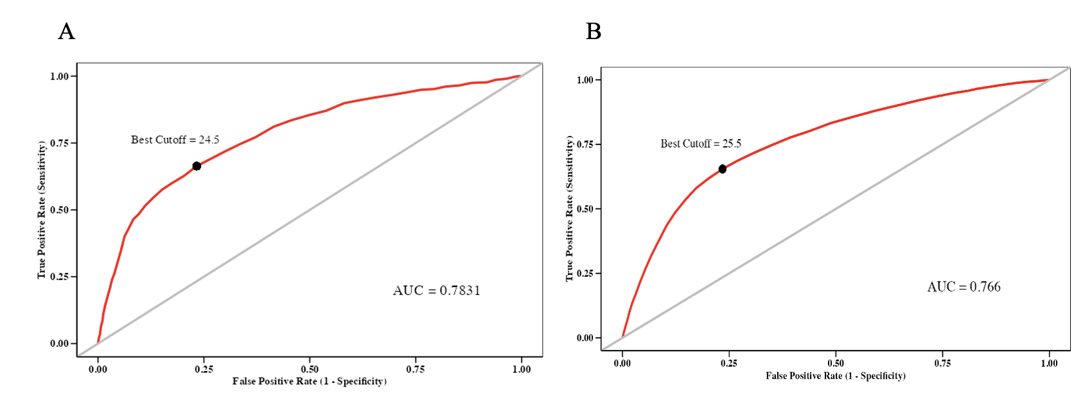

S3 Fig.ROC curves and cutoff points

(A) Hongguang (B) Bao'an

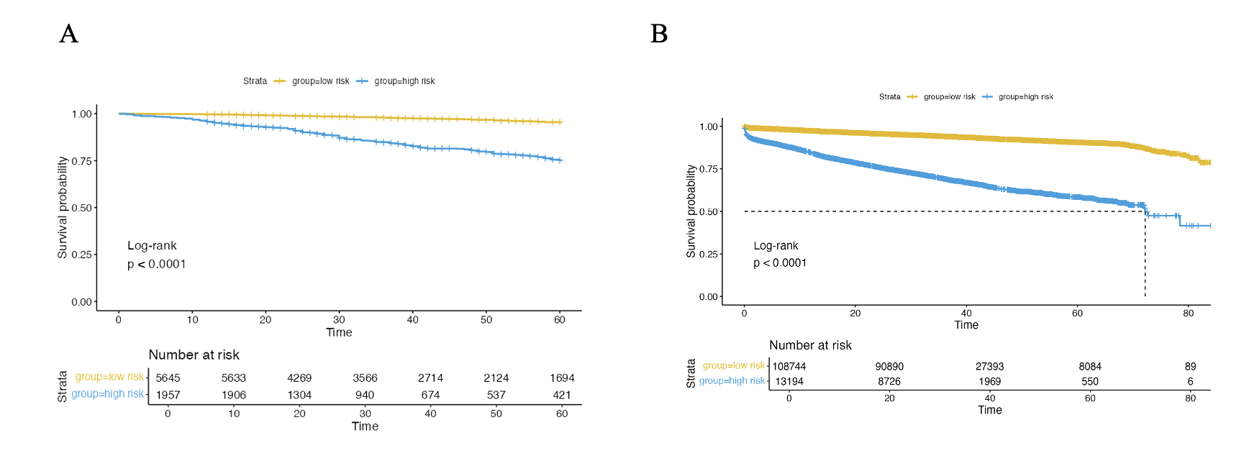

S4 Fig. KM curves of in-depth external validation

(A) Hongguang (B) Bao'an